Cellular Automata and the Spatial Dynamics of Plant Invasion: A Study in *Mathematica*

Martin Hanzel

BIO4134

Submitted

April 28 2017

University of Ottawa

# Introduction

## What are cellular automata?

Cellular automata are a class of programs that model the lives of small “cells” on a lattice. One of the most influential examples is John Conway’s “Game of Life,” in which cells interact with each other on a square grid, with each grid square representing a cell 1. Cellular automata run in discrete time. At each iteration, or *generation*, cells are born, survive, and die. Cellular automata aren’t limited to square lattices though – other spatial configurations such as hexagonal grids have been studied 2, and cellular automata have even been extended to a continuous domain 3.

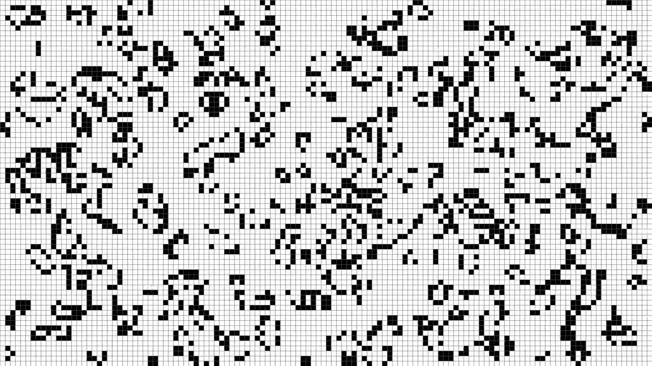

Figure 1: Example of Conway’s Game of Life on a square grid. The rules of this cellular automaton are as follows: Any live cell with fewer than two of eight live neighbours or more than three of eight live neighbours dies; Any dead cell with exactly three of eight live neighbours becomes alive. Otherwise, the cell does not change state.

At their core, all cellular automata have three basic components:

* A regular grid of “cells,” each one in a finite number of states, for example, “alive” or “dead.” A square grid can be represented by an $m$ by $m$ array of integers, with unique integers representing different states.
* A notion of a “neighbourhood” surrounding each cell. Cells are affected by other cells in their neighbourhood. Different neighbourhoods exist, and each neighbourhood yields different behaviour. For instance, a *von Neumann* neighbourhood consists of the 4 cells directly adjacent to a cell. A *Moore* neighbourhood consists of the 8 cells adjacent and diagonal to a cell. Cells need not be adjacent to be in a neighbourhood – one can define a neighbourhood as the set of all cells within an $n$-block radius. An automaton where a cell’s neighbourhood includes all other cells on the lattice is called a *global cellular automaton* 4.
* A mathematical function that maps the state of a cell to its state in the next generation. This function takes the form $f(c, N)$, where $c$ is the cell’s current state and $N$ is the set of cells in its neighbourhood. Plainly, the set of neighbouring cells can determine into which state a cell goes next.

Cellular automata are extremely useful because they are inherently spatial, and don’t require complicated partial differential equations to model diffusion in space. Their ability to simulate discrete space may provide a better approximation in plant ecology, where plants may colonize discrete patches. Finally, cellular automata can produce extremely complex behaviour given a simple set of rules, and they can often reveal unanticipated, *emergent behaviours* that weren’t explicitly programmed into the model 5. Programming a model based on such “rules” is often conceptually clearer than devising suites of differential equations.

Stephen Wolfram, the author of *Mathematica*, is one of the pioneering investigators of cellular automata. It was he who described in excruciating detail the complexity and computational capabilities of cellular automata 5, and developed *Mathematica* in part to study them. It seems fitting that we shall use *Mathematica* to study the applications of cellular automata in plant ecology.

## Objective

As mentioned above, a constant challenge with representing spatial models is devising and understanding the partial differential equations that deal with diffusion in two- or three-dimensional space. There is precedent for using different spatial models, namely cellular automata, in literature 4,6–9. However, cellular automata are not yet well-established in the scientific community. This might be due to their infancy, or the lack of suitable tooling to develop cellular automata [1].

In this work, we’ll develop a cellular automaton based on existing models to answer the question of how to predict the invasion of plant species (we use make-believe species because this is a computer science endeavour, and computer scientists dislike going outside). Later, we’ll investigate how environmental factors, such as insolation, influence the distribution of plants.

# Methods and Results

We begin by constructing a model loosely based on the one presented by Xu *et al* 7. This model consists of a square lattice on which each cell constitutes a discrete patch. Individuals may populate a single patch, and only one individual may populate a patch at any time. The state of the cell $c$ indicates which species of plant occupies it (for $c≥1$), or whether the patch is unoccupied ($c=0$). The size of the patch is irrelevant, but the reader may choose to assign a convenient value to the patch size, say, $10×10 \text{cm}$.

Xu *et al*. study two species of perennial plants in their paper. However, for simplicity, we’ll consider annual plants. Our plants grow and mature within one year, produce seeds that spread around the mother plant, then die.

Our model will have a time-step of one year. With annual plants, one iteration of the cellular automaton will correspond to exactly one generation.

We encounter a complication when considering exactly how offspring spread from their mother plant. In cellular automata, cells are influenced by their surroundings, but cannot directly change neighbouring cells. This prevents us from saying “for each plant, distribute a number of seeds randomly within its neighbourhood.” We must devise an alternate method of simulating seed dispersal.

Suppose that plants may spread seeds in a Moore neighbourhood with a 2-cell radius. Each cell in that neighbourhood has two properties: a distance $d$ between the mother plant and itself, and a probability $p$ of receiving a seed from the mother plant. This probability declines proportionally with the square of the distance between the mother and the target cell. The Euclidean distance $d$ is found trivially. For each cell, the probability $p$ satisfies the equation:

$$p=\frac{d}{Σd}$$

Where $Σd$ is the sum of all $d$-values in the neighbourhood. The sum of all probabilities in the neighbourhood will thus equal 1. The cells directly adjacent to the subject cell will have the highest $p$, while cells farther away will have a lower $p$.

Next, we distribute seeds from the mother to target cells. Suppose that a species of plant produces $q$ seeds on average per generation. We consider each target cell independently. The number of seeds the target cell receives is a function of its $p$ and of $q$. Specifically, for each cell, we draw a random value from a binomial distribution with $q$ events and success probability $p$. Note that this theoretically allows a plant to send $q$ seeds to each target cell, or send no seeds at all. These two events are extremely unlikely, and over a long period of time, each plant disperses close to $q$ seeds on average per generation.

Mathematically, the number of seeds received by a patch can be written as:

$$s=\sum_{m∈M}{B\left(q_{m}, d_{m}/Σd\right)}$$

Where $M$ is the set of plants of the same species in the patch’s neighbourhood, $B(n, p)$ is a random variable with a binomial distribution, $d_{m}$ is the distance to the mother plant $m$ and $q_{m}$ is the average number of seeds produced by the mother plant $m$. We’ll assume that all plants of the same species share the same $q$.

Seeds that fall on a patch have a perfect chance of germinating and growing. As long as there is one seed on a patch, a plant will grow. Patches may be seeded by different mother plants. However, patches may also be seeded by different species of plants. In this case, the more numerous species of seed will out-compete the others and grow. If there is an equal number of seeds from each species, no single species will out-compete the other, and the patch will remain unoccupied. A patch cannot receive a seed from the plant that is occupying it.

This model was run for 50 generations with two competing species. Initially, 8 patches were occupied by a green species and 12 patches were occupied by a red species. This configuration was obtained by picking 20 patches at random and assigning them a random species. Both species of plant produce an average of 5 seeds per generation ($q=5$). The neighbourhood used for seed dispersal was a circular neighbourhood [2] with radius 4. Figure 2 shows the result of this run.



Figure 2: State of an ecosystem measuring 101 by 101 patches. Left to right, then top-to-bottom: generation 1, (the initial generation), generation 4, 7, 10, 20, 30, 40 and 50.

Both species of plants are on equal footing, and neither shows any strong advantage over the other. Over the long term, one species will slowly consume another species’ patches if it surrounds the other species. This can be seen from generations 10 to 50 in the bottom-left corner, where green is invading surrounded red patches; and at the top, right, and bottom borders, where red is invading surrounded green patches. In generation 50, the bottom green patch is invaded completely.

The model was run again with a different initial distribution of plants: one red in the top-left corner, and one green in the bottom-right corner. Figure 3 shows the results of three simulations using this configuration. While the first and third runs show a species invading the other in the long term, the invasion is quite slow and the model provided no evidence that any one species always has an upper hand. Rather, it is chance that determines whether one species is more successful at invading the other, due to random seed distribution. The second run shows both species of plants competing at a barrier that roughly divides the ecosystem in half.

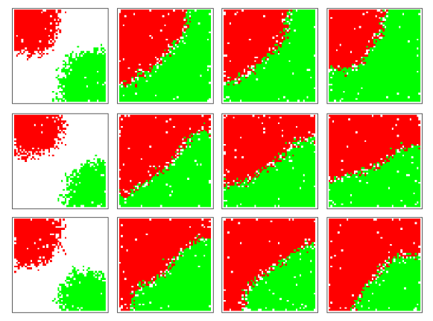

Figure 3: Time-lapse of three separate simulations where each species initially occupies one patch in opposite corners. Each row shows the outcome of a single simulation. Columns show the state of the ecosystem at generations 10, 30, 50, and 100, from left to right. The size of the ecosystem is 51 by 51 patches.

A plant may become more invasive by changing the number of seeds its species produces per generation. Figure 4 and Figure 5 show a time-lapse of an ecosystem where the green species produces more seeds than the red species. A species becomes invasive only if the difference between $q$ values of the invading and invaded species is sufficiently large. If it is small, the invaded species may repel the invader and cause a stalemate, largely driven by the configuration of patches. If the invaded species occupies patches that partially surround those of the invading species, the invading species is at a disadvantage.

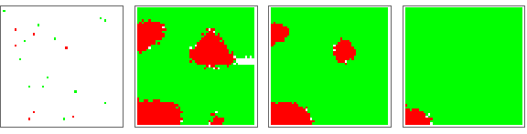

Figure 4: Time-lapse of a simulation where $q=35$ for the red species and $q=40$ for the green species. The green species clearly dominates the ecosystem. Left to right: generations 1, 5, 10, 20. The size of this ecosystem is 51 by 51 patches.

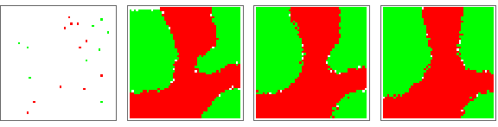

Figure 5: Time-lapse of a simulation where $q=37$ for the red species and $q=40$ for the green species. The green species does not dominate the ecosystem. Despite the green species producing more seeds than the red species, this configuration resembles the dynamics from simulations where the two species are equally competitive. Left to right: generations 1, 5, 10, 20. The size of this ecosystem is 51 by 51 patches.

## Uncertain Germination

In the model so far, each seed has a certain chance of germinating. Let us introduce a parameter $p_{g}$ for each species that represents the probability that a single seed will germinate. We will continue with the assumption that a patch will be colonized by the species that has more germinated seeds.

After calculating the number of seeds from each species received by a patch, we apply the following equation:

$$s_{g}=B(s,p)$$

Where $s_{g}$ is the number of seeds that have successfully germinated, and $p$ is the probability that a single seed will germinate. Plants may now become more competitive by increasing $p$ as well as increasing $q$. I hypothesize that the overall competitiveness of a species can be given by the following equation:

$$C=pq$$

Where $C$ indicates the degree of competitiveness.

Two simulations were run where the $p$ and $q$ parameters for both species were set such that both species had equal competitiveness. The results show that there is very little movement of the inter-species boundary, suggesting that the two species are equally competitive.

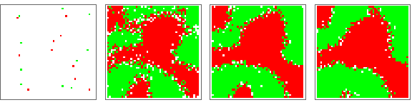

Figure 6: Time-lapse of a simulation with uncertain germination. For the red species, $q=90, p=0.1$. For the green species, $q=10, p=0.9$. $C=9$ for both species. Left to right: generations 1, 5, 10, 15. The size of this ecosystem is 51 by 51 patches.

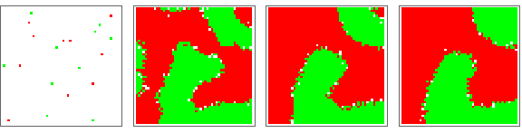

Figure 7: Time-lapse of a simulation with uncertain germination. For the red species, $q=40, p=0.5$. For the green species, $q=80,p=0.25$. $C=20$ for both species. Left to right: generations 1, 5, 10, 15. The size of this ecosystem is 51 by 51 patches. Note that this simulation has smoother edges and fewer empty patches along boundaries than the previous figure.

Changing the parameters so that the competitiveness for one species is different causes one species to invade the other. In one example, parameter values were $q=90, p=0.2$ for the red species, and $q=20, p=0.9$ for the green species. This yields $C=9$ for the red species and $C=18$ for the green species. The green species invades the red species very quickly and dominates the ecosystem, as shown in Figure 8.

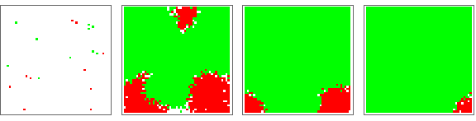

Figure 8: Time-lapse of a simulation with uncertain germination and unequal competitiveness. For the red species, $q=90, p=0.2$. For the green species, $q=20, p=0.9$ Left to right: generations 1, 5, 10, 15. The size of this ecosystem is 51 by 51 patches.

## Environmental Factors

We’ll introduce an environmental effect to our model – patches will receive unequal amounts of sunlight. Suppose that the red species requires sunlight to grow, grows best in constant insolation, and cannot grow in constant shade. Meanwhile, the green species is shade-tolerant and grows best when it receives and equal amount of direct sunlight and shade, but grows at a reduced rate when exposed to constant sunlight or constant shade.

For the simulations presented in this section, $q=20, p=1$ for the red species and $q=40, p=0.5$ for the green species. $C=20$ for both.

We’ll keep track of the amount of insolation on the ecosystem using a matrix with values ranging from zero to one. Zero indicates constant shade; One indicates constant sunlight. Let $p_{s}$ be a value between zero and one that, for each species, determines the probability of a seed growing under some amount of sunlight. We shall let $p_{s}$ affect the seed germination rate like so:

$$s_{g}=B\left(s,p⋅p_{s}\right)$$

This means that seeds growing in a patch that receives the optimal amount of sunlight for that seed type ($p_{s}=1$) will grow ideally, as in the previous section. Any deviation from the optimal amount of sunlight imposes a penalty on the seed and decreases the probability that it will sprout and grow to adulthood. Naturally, seeds growing in hostile conditions will be less competitive and more prone to invasion than seeds growing in optimal conditions.

The following plots illustrate the $p_{s}$ versus sunlight envelopes for both species:

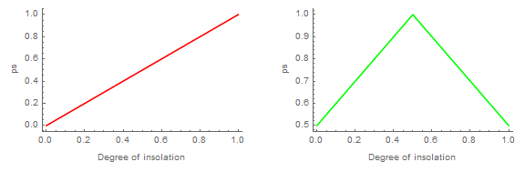

Figure 9: Sunlight response envelopes for red (left) and green (right) species.

In a field that is constantly bathed in sunlight, the red species would have the upper hand, as shown by the following figure. The red species, capable of out-competing the green species in direct sunlight, dominates the ecosystem.

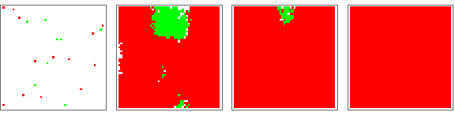

Figure 10: Time-lapse of an ecosystem bathed in constant sunlight. Left to right: generations 1, 5, 10, 15. The red species thrives in direct sunlight. The size of this ecosystem is 51 by 51 patches.

Let us introduce uneven sunlight. Consider a shady field with a constant light shining in a small, circular area in the middle of the field. Perhaps a thin ray of sunshine penetrates some dense foliage cover, or there is a UFO hovering over the field shining a spotlight there. In any case, the red species grows quickly in that area, and establishes a brief foothold that can be seen in generation 4 (Figure 11). The red species cannot grow in sunlight-poor areas, so the green species quickly dominates the rest of the field. The green species quickly grows, surrounds the middle red patch, and invades it. By the tenth generation, the green species has almost completely dominated the ecosystem.

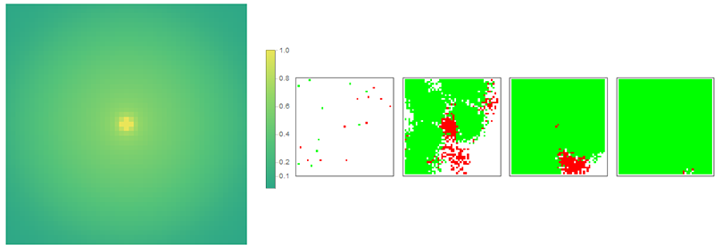

Figure 11: Simulation where sunlight shines unevenly in a circular pattern. Left: Degree of insolation. Yellow represents constant sunlight; Dark green represents constant shade. Right: Time-lapse of the ecosystem. From left to right, shown are generations 1, 4, 7, 10. The size of this ecosystem is 51 by 51 patches.

In another distribution of sunlight, the outcome is very different. Suppose that sunlight shines on the field in a striped pattern. Over many generations, the red species establishes a permanent foothold in sunny patches, and is resistant to invasion by the green species. In fact, the red species invades sunny patches occupied by the green species and establishes corridor-like regions. In generations 15 through 20, the red species manages to invade the green species in sunny patches, even though the red species is surrounded on three sides by the green species. This is in contrast to the previous figure, where the green species had the red species completely surrounded, and eventually invaded the red species’ patches.

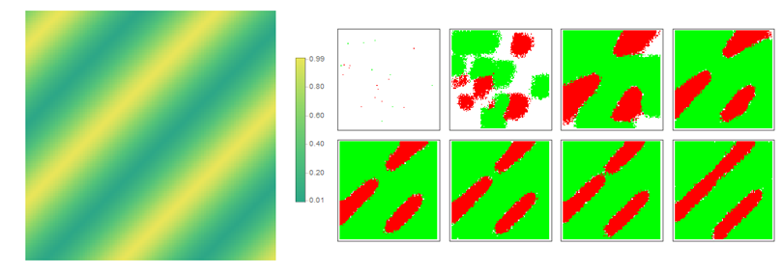

Figure 12: Simulation where sunlight shines unevenly in a striped pattern. Left: Degree of insolation. Yellow represents constant sunlight; Dark green represents constant shade. Right: Time-lapse of the ecosystem. From left to right then top to bottom, shown are generations 1, 5, 10, 15, 20, 25, 30, 35. The size of this ecosystem is 101 by 101 patches.

# Conclusions

We’ve seen that a relatively simple cellular automaton can reproduce complex spatial dynamics of the diffusion and invasion of competing plant species. In particular, we’ve seen that, in this particular model, plant competitiveness can be modulated by changing the number of seeds produced per generation by a plant species, or the probability of seeds successfully germinating.

More interestingly, we’ve touched on fascinating interactions between two plant species and their environment. If conditions are favourable, a species can invade a patch that is hostile to it, but favourable to the endemic species and drive the endemic species out of the patch. This seems to occur when the invading species can attack the patch from multiple directions. However, if a species has a suitable foothold in a large enough area, it may invade patches occupied by a species that has it completely surrounded. This finding has important consequences in conservation ecology – a species that has become uncompetitive (possibly due to anthropic effects or the introduction of an invasive species) can be saved by re-distributing it in such a way that favours expansion and invasion, despite its lower competitiveness. Certain configurations of patches are also more resistant to invasion than others, which reduces the risk of the uncompetitive species becoming extinct.

There are countless variations on the model we explored. One future direction would be to introduce a third or fourth species and observe if any species are capable of cooperating to establish themselves in a new environment. Another variation might be to add discontinuities to the physical ecosystem where plants cannot grow, such as rocky outcrops or water features, and see if certain species are more suited to invade through corridors of various width.

Cellular automata show promise, especially when modelling spatial dynamics. In some fields, such as plant ecology, their spatial nature and discrete-time and discrete-space behaviour may render them more suitable than other methods, such as differential equation models. Hopefully this paper has shown that cellular automata can be a robust tool for modeling the invasiveness of plant species.

# Works Cited

1. Gardner, M. Mathematical Games - The fantastic combinations of John Conway’s new solitaire game life - M. Gardner - 1970. *Scientific American* 120–123 (1970). Available at: http://ddi.cs.uni-potsdam.de/HyFISCH/Produzieren/lis_projekt/proj_gamelife/ConwayScientificAmerican.htm. (Accessed: 27th April 2017)

2. Siap, I., Akin, H. & Uğuz, S. Structure and reversibility of 2D hexagonal cellular automata. *Comput. Math. with Appl.* **62,** 4161–4169 (2011).

3. Rafler, S. Generalization of Conway’s Game of Life to a continuous domain -SmoothLife. (2011).

4. Mikler, A. R., Venkatachalam, S. & Abbas, K. MODELING INFECTIOUS DISEASES USING GLOBAL STOCHASTIC CELLULAR AUTOMATA. *J. Biol. Syst.* **13,** 421–439 (2005).

5. Wolfram, S. *A New Kind Of Science*. (Wolfram Media Inc., 2002).

6. Breckling, B., Pe’er, G. & Matsinos, Y. G. in *Modelling Complex Ecological Dynamics* 105–117 (Springer Berlin Heidelberg, 2011). doi:10.1007/978-3-642-05029-9_8

7. Jie Xu *et al.* A cellular automata model for population dynamics simulation of two plant species with different life strategies. in *2010 IEEE International Conference on Intelligent Systems and Knowledge Engineering* 517–523 (IEEE, 2010). doi:10.1109/ISKE.2010.5680742

8. Burzyński, M., Cudny, W. & Kosiński, W. CELLULAR AUTOMATA: STRUCTURES AND SOME APPLICATIONS. *J. Theor. Appl. Mech.* **42,** 461–482 (2004).

9. Hogeweg, P. Cellular automata as a paradigm for ecological modeling. *Appl. Math. Comput.* **27,** 81–100 (1988).

1. One of the first things an investigator learns when using *Matlab*, for instance, is how to evaluate differential equation models. Cellular automata, sadly, are not as high on the things-to-do list, and can be cumbersome to write for beginners.
2. In a circular neighbourhood, cells belong to a subject cell’s neighbourhood if the Euclidean distance between their centres is less than or equal to a certain radius.